Word 2010 Tips & Tricks

Contents

What language barrier? 2

Create eye-catching visual effects in a flash 5

Discover an improved search and navigation experience 6

What language barrier?   
Find improved tools for translation in Word

Word 2010 has great tools for anyone who’s ever worked with someone—a coworker, customer, or entire market segment—who speak a language different than their own. The improved translation tools in Word 2010 provide easy options for translating a word, phrase, or your entire document.

|  |  |  |
| --- | --- | --- |
| **Use Word Translator**  When working in a Word document, you may find the need to translate a word, phrase, whole paragraphs, or even the entire document into a different language.  Word 2010’s translation tools allow for all of the above.  [Watch this short video of Word Translate  options in action](https://academymobile.microsoft.com/Pages/PodcastDetail.aspx?itemId=44763&userId=28388&caid=&csId=%257B9C2F73CA-9622-4A7B-8971-4217F1594BFC%257D%2540%257B06D68D46-462E-4807-B0FE-9893119228B9%257D) | [cid:image006.jpg@01CA4B6B.9A25E8C0](https://academymobile.microsoft.com/Pages/PodcastDetail.aspx?itemId=44763&userId=28388&caid=&csId=%257B9C2F73CA-9622-4A7B-8971-4217F1594BFC%257D%2540%257B06D68D46-462E-4807-B0FE-9893119228B9%257D) | |
| **Send Your Document to the Web for Instant Translation**  *Step by Step:*   1. Start with a Word document you’d like to translate, and decide how much you need translated. 2. On the **Review** tab of the Ribbon, in the **Language** group, click **Translate**. You see the following options: **Translate Document**, **Translate Selected Text**, and **Mini Translator**. |  |  |

* **Translate Document** takes you out of Word and into the browser, where you see an instant machine-generated translation of your document.

|  |
| --- |
|  |
|  |
| * The **Translate Selected Text** option opens the Research pane that you may know from earlier versions of Word. You see translations in the Research pane and can easily change translation languages for the selection. * Finally, the improved **Mini Translator** allows you to point to a word and view an instant translation in a screen tip. To enable the Mini Translator, on the **Review** tab, click **Translate** and then click **Mini Translator**. You will be automatically prompted to select a translation language. |
|  |

**Note**: Get extra help from the Mini Translator for English as a second language. Click the green arrow icon, as shown in this image, for English text-to-speech playback of your selected term. 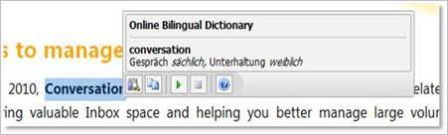

# Create eye-catching visual effects in a flash

Throughout Microsoft® Office 2010, you’ll find new and popular tools to create high impact visuals to make your work really pop.  And they take just moments to use.

**Pictures speak a thousand words**

New picture editing tools in Word® , PowerPoint® , Outlook®  and Excel® 2010 let you trim and add special picture effects without additional photo-editing software. Use the new tools to change color saturation, brightness and contrast to easily turn a boring document into a work of art.

*Step by Step:*

|  |  |
| --- | --- |
| 1. Insert a picture into Microsoft Word, PowerPoint, Outlook or Excel using the **Insert** tab on the Ribbon. 2. Click on your picture and the **Picture Tools** tab in the Ribbon appears. Click on **Format** to see all of the editing options available. Or double click on the image to trigger picture editing options right away. 3. Click **Artistic Effects** to preview more than 20 effects to apply to your photo. |  |

**Let your work stand out**

Use the new **Insert Screenshot** feature to quickly and easily capture and incorporate screenshots to complement your work in Microsoft Word®, PowerPoint®, Outlook®, and even Excel® 2010.

*Step by Step:*

1. 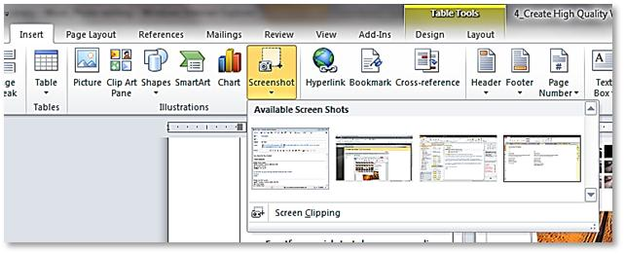Locate the image you want to capture in a screenshot.
2. Click on the **Insert** tab on the Ribbon.
3. Click on the **Screenshot** command in the **Illustrations** group.
4. Select from the **Available Screen Shots** displayed, which include any of the other windows you have open (browser window, other documents, and so on).
5. Click on the screenshot. The **Picture Tools** tab on the Ribbon appears. Select **Corrections** to sharpen, soften, or change contrast on your screenshot.

# Discover an improved search and navigation experience

|  |
| --- |
| Locating the information you need is easier and faster in Word 2010. With the new and improved **find** experience, you can now search for content by graphics, tables, footnotes and comments.  The improved **Navigation Pane** provides you with a visual representation of your document so you can browse, sort and find what you need quickly.  *Step by Step:*   * 1. Click “find” on the far right section of the Home tab on the Ribbon. * 2. Type a query in the Search navigation. * 3. All instances will come up, in the context of any assigned headings. Click to jump to that location in your document. |

